ST10438554
Due Date: 14 November 2025
Human Computer Interaction (HCIN6222)
POE Prototype

Table of Contents
Introduction 3
Prototype Overview 3
Usability Goals and Implementation 4
Efficiency 5
Error Prevention and Recovery 5
Accessibility and User Satisfaction 6
Aspects of User Experience 6
Visual Appeal and Personalisation 7
Cognitive Load Reduction and Social Connection 7
Design Principles and Screen Application 8
Interaction Types 9
Social and Emotional Interaction 9
WCAG 2.1 Compliance 9
Observable 10
Operatable 10
Intelligible 10
Strong 10
Screen-by-Screen Summary 11
Conclusion 12
References 13

Introduction
In the CampusPulse project's third phase, the interactive prototype was improved using the in-depth input from Part 2. A more thorough examination of the system's operation and compliance with Human-Computer Interaction (HCI) principles was necessary for this phase. The goal was to improve the system's overall usability, accessibility, and emotional resonance in addition to fixing little problems that had previously been found. The absence of a single, integrated platform that allows students to keep track of events, vote on campus initiatives, RSVP for events, and remain informed about upcoming engagements is a major issue seen at many academic institutions.CampusPulse offers a unified digital solution that is intended to improve communication and simplify the student experience in direct response to this difficulty.

In order to ensure that theoretical notions were more accurately translated into interface-level decisions, Part 3 reviewed and refined the conceptual design generated in Part 1 and the initial prototype created in Part 2. The prototype's architecture and interface design leverage Visual Studio Community 2022's event-driven environment and user-friendly design tools. It was created using C# Windows Forms. The four main screens Login, Dashboard, Event Details, and My Calendar were improved to support usability, preserve a unified visual identity, and give students easy-to-use interaction paths. The modifications made during this stage show how a conceptual notion may be developed into a useful, user centered system using an HCI-informed design methodology.

Prototype Overview
Instead of being a web-based system, the revised prototype is still a desktop application. This design choice was selected on purpose since Windows Forms is lightweight, reliable, and very compatible with entry-level devices that students frequently utilize. Learnability is supported by its consistent behavior and well-known interaction patterns, which is crucial for new users in particular. Additionally, the development environment facilitates rapid iteration, which makes it appropriate for academic prototypes that require constant improvement.

Presentation Layer - The presentation layer consists of all user-facing forms, including LoginForm, MainForm, EventDetailsForm and MyCalendar. These screens handle user interaction through buttons, text boxes, drop-down menus and list views. Each screen follows consistent spacing, alignment and colour use to ensure a clear and cohesive interface.

Logic Layer - This layer performs the essential operations such as validating email addresses, processing RSVP toggles, filtering events based on category and updating the poll choices. It also manages interface behaviour such as font scaling, which supports accessibility by allowing users to adjust text size according to their needs.

Data Layer - The data layer uses lightweight in-memory structures, simulated through Event.cs and DataStore.cs. Although not connected to a real database, these classes behave like a backend by storing event details, RSVP statuses and poll options. This design simplifies data retrieval and allows the prototype to function smoothly without requiring a fully developed server component.
The enhancements performed in Part 3 made sure that the prototype's design, structure, and essential features matched the previously stated HCI objectives, resulting in a more robust and cohesive system.

Usability Goals and Implementation
During this stage, usability continued to be a top priority. With each update, the goal was to build a system that would enable students to learn rapidly, navigate with ease, and finish work swiftly. In accordance with Nielsen's (1994) recommendations on efficiency, error prevention, system visibility, and user control, the prototype now incorporates usability more thoroughly.
Ease of Navigation -
The system's navigation was improved to be predictable, logical, and linear. To lessen cognitive strain, the connections between the Login screen, Dashboard, Event Details, and My Calendar were streamlined. A more seamless user experience is supported by consistent button placement, clear labels, and instantly identifiable iconography.
Login Screen - To reduce reluctance, the interface was intentionally made simpler. A conspicuous login button and a single text input box are presented to users. A help link that is placed just beneath the form offers assistance to consumers without overwhelming them.
Dashboard Screen - Upon logging in, the event list loads immediately, guaranteeing instant access to pertinent data. Users can change what they view without going to different pages thanks to the drop-down category filter. These components support the upkeep of a clear, effective flow.

Event Details Screen - Readability is given first priority while organizing information. Details are presented in a single, readable column after event names, which are bold and large. Quick selections are made possible by the prominent placement of the RSVP button.
Calendar Screen - RSVPs and polling choices unique to each user are summarized on this screen. It takes less time to complete interactions since the "Vote" or "Poll" button is positioned in the centre, making it easy to find.

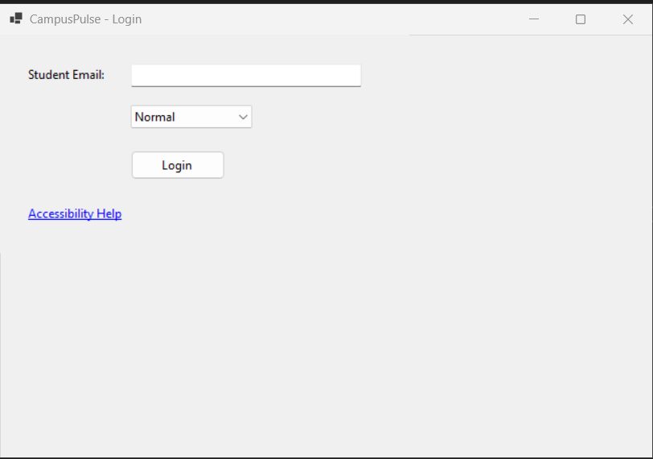
Screen 1

Efficiency
Reducing the number of steps needed to do important tasks and making sure the system reacts quickly improves efficiency.
Some examples are:
- Users don't have to manually refresh events because they load automatically.
- There is no need for additional confirmations; the RSVP button updates quickly.
- Later on in the process, failed login attempts are prevented by email format inspection.
- By aggregating personal activity, the My Calendar tab removes the need to recall past RSVPs.

Students can concentrate on the content instead of navigating the program thanks to these improvements, which make the experience quicker and more seamless.

Error Prevention and Recovery
By implementing Nielsen's recommendations for user control and helpful error recovery, error management was improved. Errors are now more efficiently prevented by the system, and when they do happen, it gives explicit explanations.
Important characteristics include:
- Real-time email validation makes sure that only institutional emails with proper formatting are accepted.
- Reversible actions, such tapping the same button again to cancel an RSVP.
- Contextual prompts, like trying to access details without choosing an event, only show up when required.
- Simple language in error notifications to prevent intimidation or misunderstanding.

These changes lessen user annoyance while giving users a sense of power and confidence.

Accessibility and User Satisfaction
To make sure that students with a range of needs and skills could use the system, accessibility was given top priority. A dedication to inclusive design is shown by the use of scalable font alternatives. The common font-size selection panel on the Login screen was used to incorporate this feature into all forms. Once chosen, the font size is applied uniformly throughout the sample, making it easier for people with visual impairments to read.
While the logical tab sequence guarantees that keyboard-only users may easily navigate the system, high contrast text enhances visibility. Because people gain from a design that functions in various settings, this enhances both accessibility and general usability.
From an emotional standpoint, careful design decisions increase enjoyment. A nice, approachable system is enhanced by encouraging verbiage, courteous instructions, and positive confirmation messages. Reliability is strengthened by seamless transitions, few delays, and consistent behavior. Because emotion affects perception, even minor language decisions have a big effect on the user's mental image of the system (Norman, 2013).

Aspects of User Experience
Both pragmatic (functional) and hedonic (emotional) traits are emphasized in Hassenzahl's (2010) approach. Both are enhanced by the changes in Part 3. In addition to operating efficiently, the system strives to produce a pleasurable, interesting, and significant experience.

Visual Appeal and Personalisation
The prototype steers clear of superfluous adornment in favor of a simple, organized appearance. A restricted color scheme avoids visual clutter, and a light backdrop with dark lettering enhances reading. A professional look that is constant across all displays is achieved by the subtle usage of icons, spacing, and alignment.
Additionally, the features for personalization were enhanced. The system feels more personalized because the Dashboard uses the user's institutional email address to display a welcome message. Only events that the student has chosen to interact with are shown on the My Calendar screen, which promotes sustained use and strengthens a sense of ownership.

Cognitive Load Reduction and Social Connection
The prototype's information is categorized and stacked to lessen cognitive load. Only the most important event summaries are displayed on the Dashboard; in-depth explanations can be found within the Event Details pane. By doing this, clutter is avoided and users are able to concentrate on pertinent tasks.

Features like these promote social interaction:
- Students can see who else is interested in events by looking at visible attendee lists.
- Students are given a sense of agency and community involvement through the voting element.
- Dialogues for interactive feedback that recognize user involvement.
These components foster a feeling of community, which is beneficial in a campus setting.

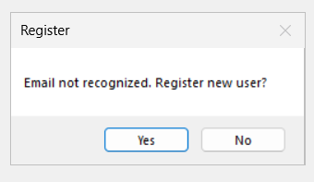
Screen 2

Design Principles and Screen Application

Principle | Expanded Application
Consistency | Shared spacing, font styles, button sizes and layout patterns ensure that each screen feels familiar. Users can rely on predictable behaviour and do not need to relearn interface elements.
Visibility of System Status | RSVP counts update immediately, pop-up confirmations provide reassurance, and selected items remain highlighted to reflect user actions.
User Control and Freedom | Users can easily reverse actions, switch between screens, or navigate back without encountering unnecessary restrictions.
Simplicity and Minimalism | The design avoids excessive text, redundant controls and visual noise, supporting a streamlined and calming interface.
Accessibility | Font scaling, keyboard navigation and high-contrast design were implemented to support diverse user needs.
Aesthetic Design | Balanced layouts, structured groupings and clear hierarchies help maintain a visually appealing interface.
Flexibility and Efficiency | Both novice users and more experienced students can complete tasks quickly using either keyboard shortcuts or mouse interactions.

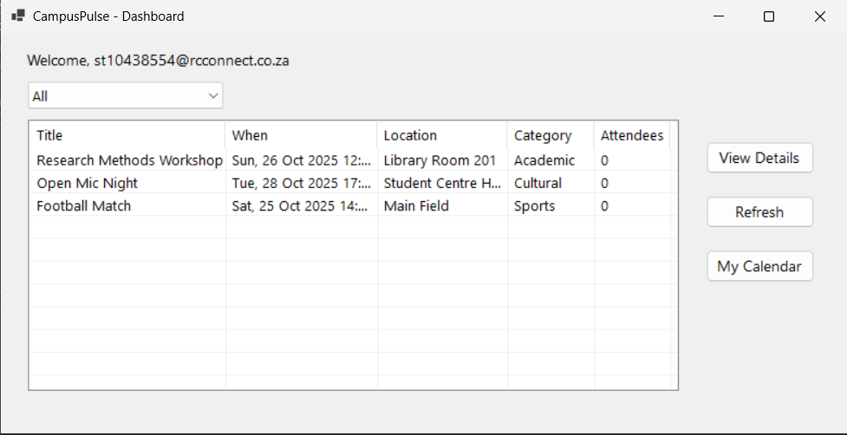
Screen 3

Interaction Types
The prototype has four interaction types to accommodate various user demands and preferences, in accordance with Preece, Rogers, and Sharp (2019).

Interaction Type | Expanded Description | Example
Instructing | Users issue commands to the system through clearly labelled buttons and actions. | Clicking “Login,” “RSVP,” or “Vote.”
Conversing | The system communicates with users through pop-up messages, confirmations and error notifications. | “Invalid email format” or “You have RSVPed.”
Manipulating | Users interact by selecting or highlighting objects, similar to physical interaction. | Choosing an event from the list view.
Exploring | The user browses through categories, menus and filters to discover information. | Filtering events by category.

Social and Emotional Interaction
Student engagement is significantly influenced by social and emotional contact. The prototype has subtle but significant elements that promote involvement and foster a feeling of community. The list of attendees encourages conversation and shows common interests. The poll element encourages agency and involvement by giving students a say in future events. Additionally, the interface feels friendly and anxiety is lessened by the positive language used in feedback messages.
Another example of emotive design is the Help link on the login screen. It recognizes that some users might not grasp the login criteria right once and offers a mechanism to get help, which can boost user confidence and lessen irritation.

WCAG 2.1 Compliance
In accordance with the POUR principles of WCAG 2.1, the prototype includes accessibility modifications:

Observable
Readability is aided by structured headings, strong color contrast, and scalable fonts. Color is not the only medium used to communicate important information.

Operatable
Keyboard navigation is applicable to all interactive elements. Large, widely spaced buttons are designed to accommodate users with poor dexterity.

Intelligible
Consistent patterns, straightforward language, and predictable behavior make it easier for users to grasp how to finish activities.

Strong
Screen readers and other assistive technology are guaranteed to work when standard Windows Forms controls are used.
A far wider spectrum of students will be able to access and utilize the system thanks to these enhancements.

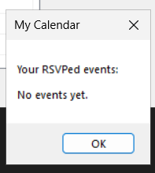
Screen 4

Screen-by-Screen Summary

Screen | Expanded Purpose and HCI Contributions
LoginForm | Serves as the entry point to the system, verifying email format and providing font-scaling options. Ensures high learnability, prevents login errors and supports accessibility from the very first screen.
Dashboard | Acts as the central hub for browsing campus events. Supports exploration, filtering, efficiency and overall design consistency. Users can navigate quickly and focus easily on upcoming events.
EventDetailsForm | Displays important information in a clean structure. Enables RSVP control, social interaction through the attendee list, and provides clear immediate feedback.
My Calendar / Poll | Offers a personalised summary of the user’s activities. Strengthens emotional engagement by showing only the events the user has interacted with. Polling supports social participation and campus involvement.

Conclusion
The development of the revised CampusPulse prototype shows how abstract HCI ideas may be converted into obvious design enhancements that significantly improve user experience. Every modification made in Part 3 demonstrates a deliberate attempt to enhance usability, accessibility, and emotional appeal, demonstrating that thoughtful design decisions have a big impact on how people view and engage with a system.
Additionally, the procedure improved comprehension of HCI topics including emotive design principles and Nielsen's heuristics. By putting these concepts into practice in a working prototype, it became clear how crucial it is to create systems that not only satisfy functional requirements but also provide users a sense of support, confidence, and engagement. Thus, the finished prototype provides a solid basis for future improvements or growth into a fully operational campus information system in addition to validating the design choices made in previous stages. CampusPulse demonstrates how careful design may produce digital tools that enhance daily student life by transforming a conceptual idea into a useful interface.

References
Hassenzahl, M. (2010) Experience Design: Technology for All the Right Reasons. Morgan & Claypool.
Nielsen, J. (1994) Usability Engineering. San Francisco: Morgan Kaufmann.
Norman, D.A. (2013) The Design of Everyday Things: Revised and Expanded Edition. New York: Basic Books.
Preece, J., Rogers, Y. and Sharp, H. (2019) Interaction Design: Beyond Human–Computer Interaction. 5th edn. Chichester: Wiley.
Shneiderman, B., Plaisant, C., Cohen, M., Jacobs, S., Elmqvist, N. and Diakopoulos, N. (2017) Designing the User Interface: Strategies for Effective Human–Computer Interaction. 6th edn. Boston: Pearson.
Tractinsky, N. (2004) ‘Towards the study of aesthetics in information technology’, Proceedings of the 25th International Conference on Information Systems (ICIS), pp. 771–780.
World Wide Web Consortium (W3C) (2018) Web Content Accessibility Guidelines (WCAG) 2.1. Available at:(Accessed: 11 November 2025).

